**Git Lab 1**

1. **Check Git Version**

Checks if Git is installed and shows the installed version.

Output:

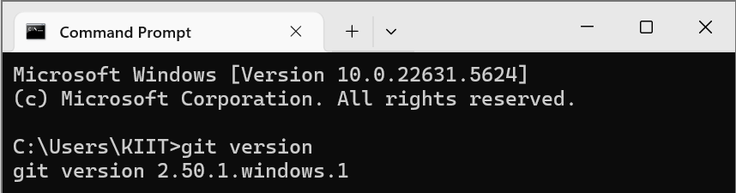

1. **Configure Global Username and Email**

Sets your Git username and email for all repositories on your system.

Output:

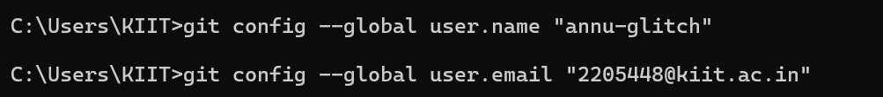

1. **Verify configuration**

Displays all global Git configurations currently set.

Output:

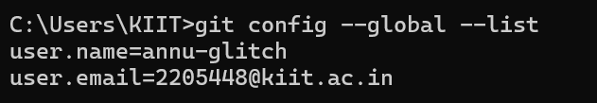

1. **Set notepad as default editor**

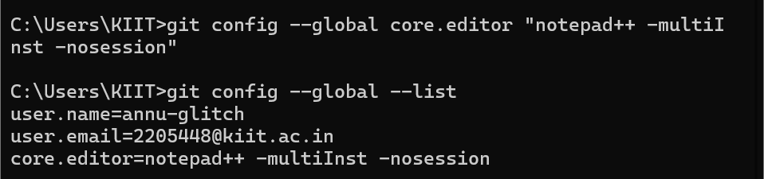

1. **Create project folder and initialize repository, create a file, check status for untracked, committed, staged files**

**Output:**

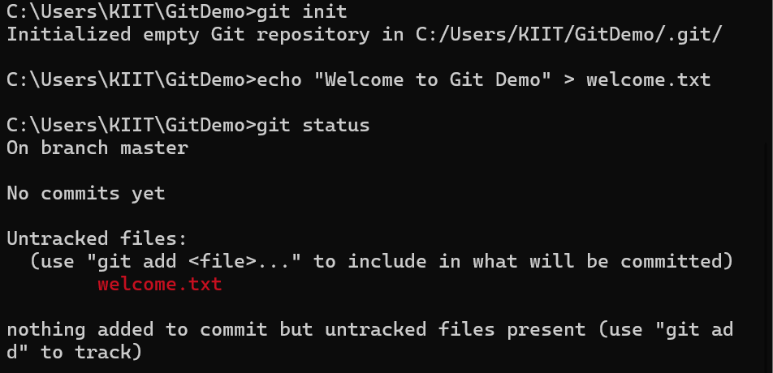

1. **Stage the modified file using git add and commit**

**Output:**

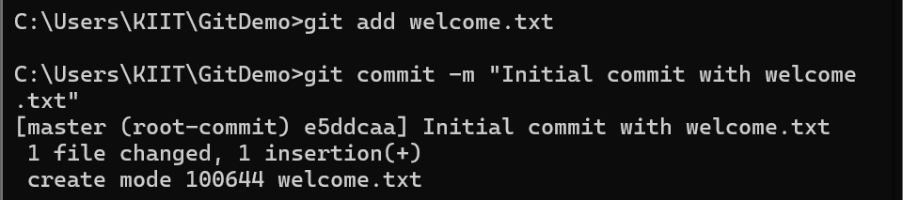

1. **Link to remote repository on GitHub and push changes to master branch**

**Output:**

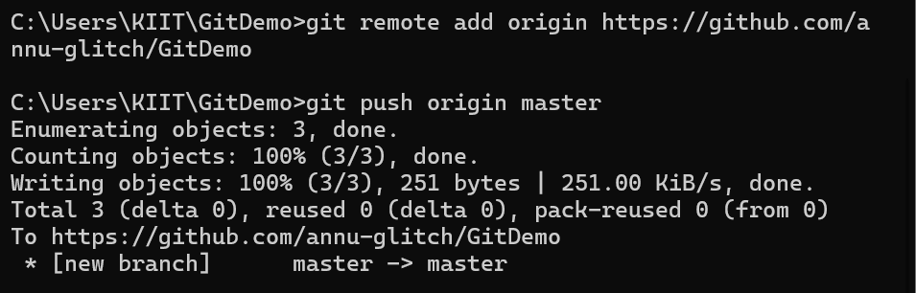

1. **Changes reflected in remote reository on Github**

**Output:**

